First Grade Homework

Reading ~ 15+ minutes every night

Here are some suggestions that may make the activity extra fun:

• Children read either their trick words or a book to a stuffed animal, pet, or family member.
• Children can set up their toys and role play being the teacher or parent reading to their toy class or toy family.
• Children read while looking into a mirror.
• Χhildren read their book using a magnifying glass.
• Children can make a cozy “reading nook” from blankets, pillows, and small furniture. Then, they can read there by themselves.
• Help children search YouTube for sight word lists and for story readings of their favorite books.

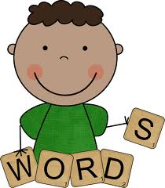
Trick Word Practice~5 minutes every night, please see Fundations Trick word list, by unit and week at the end of this document.
Here are some fun ways you could practice:
• Children can trace the word on a family member’s back for them to guess what the word is, then swap.
• Children write each new trick word largely on a piece of paper and hang it in their room. When they are read to at night, they have to repeat those words in a robot, or other silly voice when they hear them in the story.
• Children can type their trick words in a word document and make each one in a different font then print it.
• Students can design a new placemat for the dinner table each week. They can write their trick words around their mat. Family members can quiz them.
• Have children make a word search using their trick words.
• Write each trick word on a strip of paper. Place one strip on each step of a flight of stairs and have children read/spell as they step next to each word.
• Write trick words on toy cars and trucks. Race them down a hill to see which one wins.
• Children record trick words on separate slips of paper. Hide them around the house and ask children to go on a spelling word hunt, play hot and cold as they get closer, or further, from their words.
• Record words on separate slips of paper, each with various point values and stick to a wall. Invite children to throw a soft ball at each word. They must read and spell each word they hit with the ball. If they hit it, read it and spell it correctly they receive that point. An adult or another child can keep tally.
• Use a permanent marker to record chosen spelling words onto a beach ball. Toss or roll the ball to each other. As you catch the ball, read the word that faces you then throw it back.
• I spy word hunt, searching for and highlighting select sight words in magazines, newspapers, flyers, pamphlets, catalogues, recipes, menus, food packaging or in the community.
•Write sentences using trick words (perhaps 2-3 in one sentence) then illustrate to match each sentence.

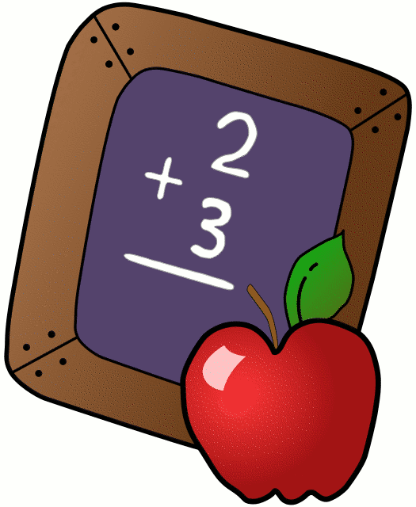
Math~5 minutes every night practicing addition facts to 10 (and once those are automatic, to 20)
Here are some fun ways you could practice:
•Play with dice – roll two dice and call out the sum of the two numbers you rolled
•Flashlight math – Flip over two flash cards. Kids shine a flashlight on the one they know and answer that one. Simple. Don’t have a flashlight? Make a math wand or use a stick or light saber.
•Play ‘Top-It’ (formerly known as ‘War’) with a deck of cards
•Use electronics – Perhaps the My Math Flash Cards App on the iPad or Math Practice Flashcards for your android phone.
•Write the answer... Or paint the answer: water on cement or chalk on sidewalk or window crayon on window. One person flashes the cards and the other writes the answer.
•Use standard flashcards or one of the following math websites:

http://www.abcya.com/math_facts_game.htm

https://www.ixl.com/math/grade-1 (Remember our focus is on addition facts to 10 so activities B.12, and then B.14 or B.22)

http://www.thegreatmartinicompany.com/

https://xtramath.org/

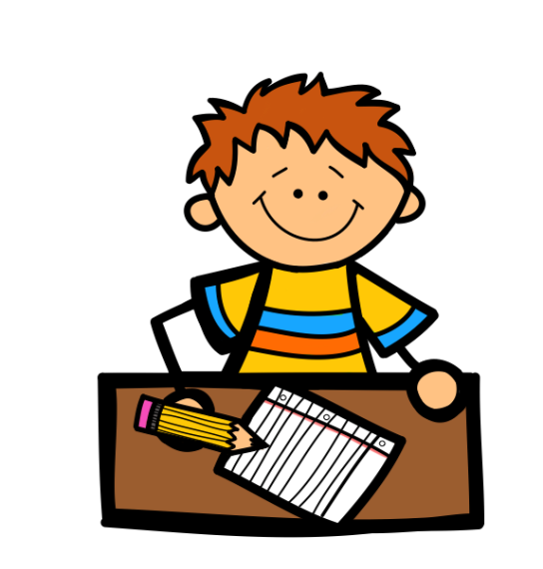
Additional Options

Writing

• Children record the names of the children they played with this past week.
• Children could write down what they ate today. If they do this for breakfast, lunch, and dinner they are working on the story elements of beginning, middle and end in story language.
• Children write a shopping list.
• Children write down the ingredients you used while preparing or cooking a meal.
• Children can write three facts about their favorite animal or place.
• Encourage children to investigate a place the family will visit this year. Record a list of things they can do while there.
• Ask children to find a given word (perhaps a trick word) from a book they are reading. Use a magnifying glass or glasses for fun. Ask them to record the word whenever they find it.
• Children can write in a journal every day. They can pick out a special notebook with a cool pen or pencil.

Non-Traditional Interest Based Projects

(Optional, so whenever the children want to do one!!!)

• Children choose something that interests them and make a plan to learn about it. Maybe check out some books on the topic from the library or visit a museum, special place, or website.
• Children decide how they will show what they’ve learned. Maybe make a sculpture, write a song, build a model, make a drawing, a piece of writing, a slideshow, etc.
• Children will complete the project and bring it to school. It can be shared with the teacher and possibly with the class.

